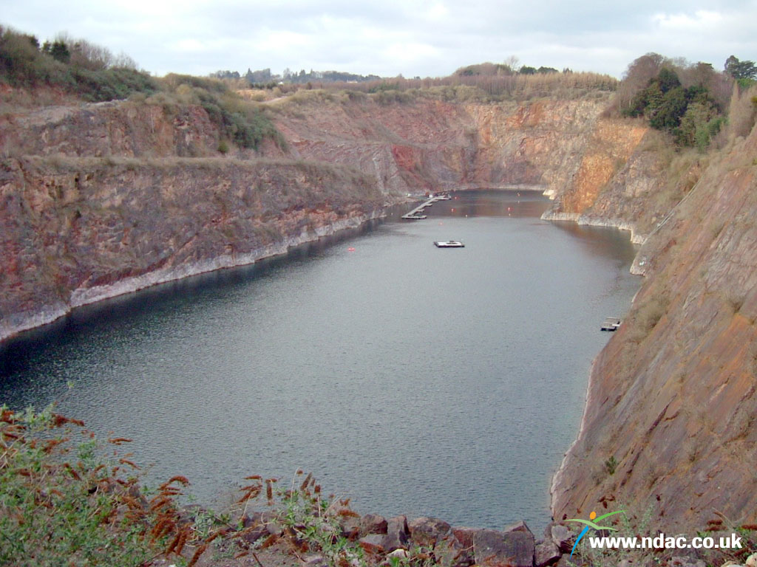

NDAC Chepstow

Start your Aventure

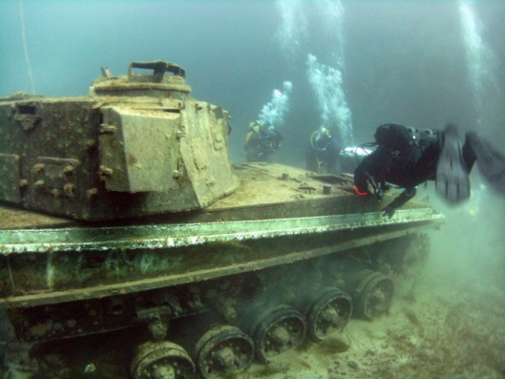
Itinerary Nitrox, Deep, Wreck, Drysuit, SMB
Date 10th & 11th December 2016
This Venus is an excellent location for you to expand your diving experience. There are plenty of objects that have been
deliberately sunk here for all divers to practice skills and to Make the interesting..

Wreck
There are some very good wrecks where you will learn
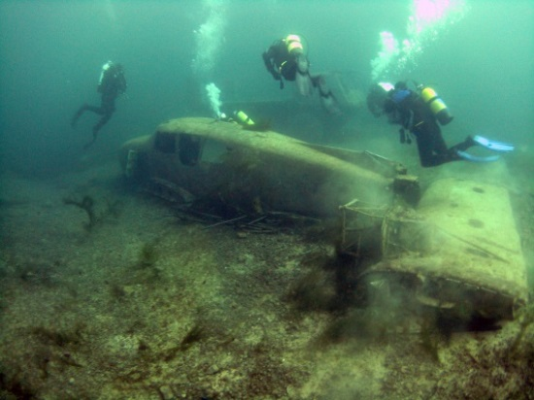
potential hazard and practice wreck penatration skill in a safe enviroment. A must before Diving in the channel. Not interested in wrecks, forget them as that and see them as artificial reefs because there are huges amounts of fish that
live on these ‘REEFS’
Deep
Here you can learn how to dive deeper safetly so you get to
see and feel the effects of pressure and what narcosis starts
to feel like.
Nitrox
Want to stay down longer? This site offers plenty of
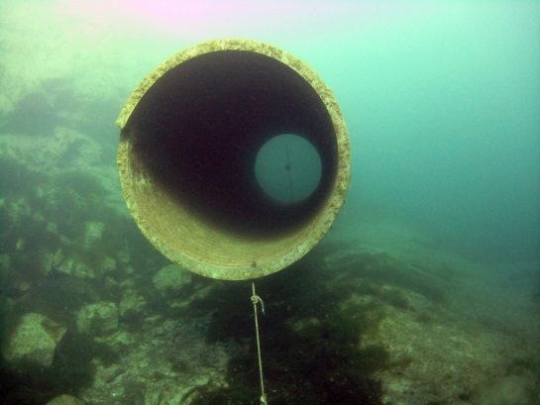
opportunity to practice your dives with more Oxygen enabling
you to have longer dives while gaining an awarness of the
problems of oxygen toxicity.
SMB
SMB & DSMB use are simple to use skills to identify your location, but they are also a skill that has issues that are regularly problematic for experienced divers in dark and or
deep dive sites as well as inexperienced. Learn what they are
and how to avoid them and make sure your not a lost diver.
Dry Suit
UK diving is fantastic January to December and offers some of the best
dive sites in the world.. but at 2 degrees during winter, the thought will
put most people off.. learn how to stay dry and warm And enjoy the
abundance of wrecks that the rest of the world can only dream of.

To book one of these Specialities or even to just come diving click on the booking button.

